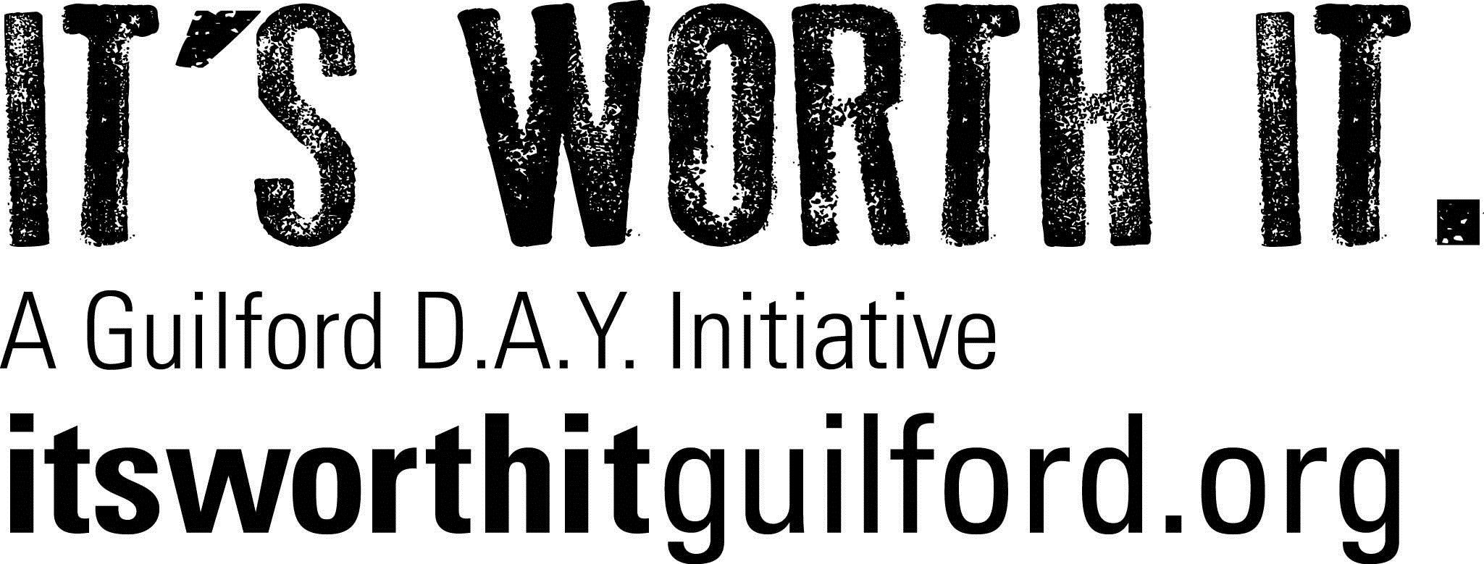

DAY Council Meeting minutes
January 17, 2017

In attendance:

- Staff: Lyne Landry, Karolin Regan, Robyn Sneider (new Prevention Coordinator)
- Executive Members: Bo Huhn, Lorri Hahn, Lisa Ott, Danielle Ott, David Melillo
- Council Members: Sue Kruczek (concerned parent), Ryan Hocking (Project Courage), Detective Marilisa Anania, Alice Slate (concerned parent), Anthony Slate (DAY Youth co-chair), Noreen Tucker (concerned parent), David Knapp (retired educator and youth leader)

2016 SEARCH Institute Survey Results: Karol Regan and Bo Huhn presented the 2016 results and compared new data with 2014 data. The results are extremely positive and indicate kids who are staying clean are in the majority. Bo attributed the results to all we do as a coalition to get people involved and aware, including Project Purple, Chris Herren, Back to school and Halloween events, etc. Lyne Landry asked Karol to research why gender was not indicated in our data since it always has been in the past.

Community forum on potential legalization of marijuana: As part of our goal to educate and inform our community on the effects of marijuana use for our youth, we are hosting a community forum on Wed, January 25, at 7 pm. We are collaborating with Clinton and Madison coalitions on this effort. Robyn Sneider shared the full-page ad we created and will appear on January 19 in The Courier, Harbor News (Clinton and Westbrook) and The Source (Madison). See attached ad and please join us if you can! We have legislators and public health experts committed to speak on the current climate in Hartford and the latest scientific facts. Gabby Palumbo, a DAY youth co-chair will also speak on the student perspective of the potential legalization of marijuana.

DAY coalition members discussed how best to promote the forum and several members agreed to share at their churches. Anthony Slate and Pete Palumbo will distribute flyers at upcoming GHS hockey game and throughout town. Alice Slate will try to send to parents via PTO. Sue Kruczek agreed to share with our legislators. Lorri Hahn will share with staff at GHS, post on GHS website and TVs. MADE and PiC (Madison and Clinton prevention coalitions) are also promoting within their communities. Karol will request ad be posted on town fb and we will add to DAY website. David Knapp said he is reaching out to CO legislator to get his views. Sue will share with Guilford Pediatrics.

Additional legislative outreaches: Bo Huhn reported that we have a tentative date for a press conference in Hartford for February 15 at 10 am (since confirmed). Dr. Niehoff has agreed to make all state superintendents and school administrators aware. Bo explained that Guilford DAY is making the core effort. Bo shared that 30 emails went out from DAY youth and the Colorado report was mailed to all legislators, indicating the impact of legalization of marijuana in their community. David Melillo shared that he thought Karol, Bo and all of Guilford DAY should be recognized for their outstanding efforts. Karol indicated that there will be a presentation on our legislative efforts made at the upcoming CAPP meeting for members to share with their coalitions. Bo also mentioned that Dr. Petit is willing to join our efforts; he’s a physician now involved in the legislative efforts after tragically losing his family in the Cheshire home invasion.

2017 Action Plan: Karol distributed the revised action plan, indicating it had been approved by the Executive Committee. The Council voted to approve as well, so it will be submitted as is.

Early Dismissal Day event: Karol shared the promotional flyer for this event, which will be held on January 25 from 1-3 pm at the Community Center for Adams and Baldwin students.

2017 DAY Week: Lisa announced that DAY week will take place from 5/13-5/20, with a color run on 5/13. A separate meeting will be held on 1/31, at 7 pm (revised time), at Youth & Family Services. Lyne indicated the budget for DAY week is ($7000), the same amount spent last year. Bo suggested we sell purple flags for parents to put on their lawns. Lisa indicated the GHS DAY group would like special shirts. Bo will invite Lifelinx to be involved.

CADCA: Robyn discussed that she and Noreen tucker will attend this upcoming conference in February where they will learn from legislators and prevention experts. Lisa mentioned the experts at CADCA are quite approachable.

Merchant Educational Event: Detective Marilisa Anania reported that the event will take place on February 7 at 9 am in Police Department community room. It is being sponsored by DiCello Distributors, the Liquor Commission and Guilford DAY. The goal of this program is to readdress issues with fake IDs and under-age access. A flyer will be hand delivered by police officers to all of the establishments in town that sell liquor. Karol (and possibly Pete Palumbo) will speak at the event. Marilisa indicated a follow-up event will be a check to ensure establishments are following the correct procedure.

LEAD Conference: The first planning meeting will take place on Monday, January 23, at 3 pm at Morgan High School. Robyn requested youth volunteers accompany her. Danielle Ott agreed to participate and indicated she would try to recruit others.

Other information shared:
- Alice indicated she was approached by a speaker to do an event at the High School. Karol thought it would be something to consider for DAY week. Alice will research and bring more information to next Council meeting.
- Marilisa mentioned there’s an excellent film called, “If Only,” which is a Wahlberg youth association effort.
- Robyn shared that the film “Generation Found” is an outstanding documentary that would be worth considering to share within our community. Although it has a focus on treatment, it also ties in very nicely with parent perception and the need for prevention and positive asset development.

Next DAY Council meeting: Tuesday, March 21 at 7:00pm. Location: Unless otherwise indicated, Guilford Youth & Family Services, 36 Graves Avenue, Guilford.

